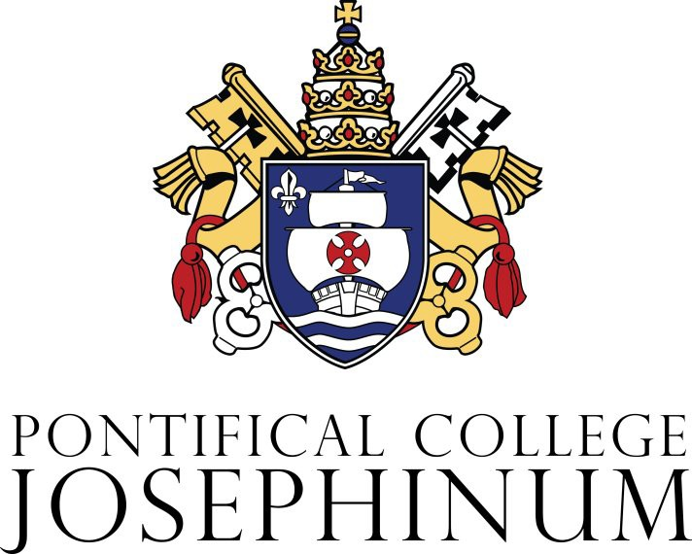

APPLICATION AND
ADMISSION GUIDELINES
FOR THE
MASTER OF ARTS in PASTORAL STUDIES

THE JOSEPHINUM DIACONATE INSTITUTE

TABLE OF CONTENTS

Pastoral Ministry in the Church 4
Admission Guidelines 4
Applicant Requisites 4
The Application Process 4
Application Forms 5
Supporting Information 6
Admission Interviews 6
Admissions Team 6
Admission Notification/Next Steps 6
Admission Processing Fee 6

Dear Friend:
The enclosed norms and guidelines for the application and admission process to the Distance Learning Masters in Pastoral Studies program at the Josephinum Diaconate Institute reflects the Church’s commitment in preparing and supporting the ministry of the Permanent Diaconate. Since 2007, the Josephinum Diaconate Institute has been forming men in preparation for ordination to the permanent diaconate and for the ongoing formation of permanent deacons and their colleagues in ministry which is always at the service of the Church.
The application process for the Master of Arts in Pastoral Studies at the Josephinum Diaconate Institute is more than an academic exercise, it is a component in the ongoing discernment of pastoral service in the Church. The Sacred Scriptures are replete with stories of how Divine Revelation unfolds within the context of the human condition. Moreover, the divinely inspired call of the Apostles by Jesus Christ was in the context of a human mediation. So, it is with discernment that applicants consider their own human abilities to determine if they are ready and capable of embracing the demands and joys of this formation program.
As the Church continues her pastoral mission in leading the faithful to the heavenly Kingdom, let us pray that more men will be open to the Lord’s call in serving the Church as permanent deacons. May the application process be a time of serious discernment, good prayer, and an affirming experience as you deepen your relationship with God and the Church.
Sincerely yours in the Lord,
Very Rev. Steven Beseau, STD
President/Rector

Application and Admission Guidelines for the Master of Arts in Pastoral Studies (MAPS) Program at the Pontifical College’s Josephinum Diaconate Institute.

Pastoral Ministry in the Church

- The Pontifical College Josephinum is implementing a Master of Arts in Pastoral Studies program in conformity with the National Directory for the Formation, Ministry and Life of Permanent Deacons in the United States. The Master of Arts in pastoral studies program is predicated on the willingness and commitment of the student to dutifully observe all the norms, requirements, and processes of the application and formation process.

- The principal focus of the MAPS program is the formation of Permanent Deacons and other church ministers for service in the diocese, parish and community. The MAPS program welcomes deacons, candidates and all in Church ministry who wish to better serve their communities, recognize their continuing formation activities and achieve certification to their having reached a level of ministerial professionalism in their ministry.

Admission Guidelines

- Admission to the MAPS program is the first step in an intense journey of formation that requires embracing the four dimensions of ministerial formation (intellectual, pastoral, spiritual and human). While the MAPS program focuses primarily on the intellectual dimension, the candidate for the MAPS is expected to actively seek to develop along the human, pastoral and spiritual dimensions. Therefore, MAPS students begin by documenting their ministerial goals and developing a plan for supervised pastoral service. These goals and plans are part of the application process and are monitored and reviewed during the MAPS formation process. To enter into the MAPS process is to embrace the challenge to enhance their service to the Church and integrate their ministry across all of the four dimensions.

Applicant Requisites

- Applicants to the MAPS must hold a baccalaureate or higher degree from an accredited college or university.

- Applicants must commit to the MAPS program of studies which include three, three-day on campus seminars at the beginning, middle and end of the course of studies. The course of studies includes 18 core credits, 8 specialized ministry credits, 2 deacon seminar credits and 6 on campus pro-seminar credits plus a two-credit thesis paper for a total of 36 credits. A limited number of courses taken at the Josephinum and other accredited institutions of higher learning may be applied to the specialized ministry credits.

The Application Process

- All completed application materials will become the property of the Josephinum Diaconate Institute and the Pontifical College Josephinum. The applicant must sign the consent forms acknowledging the right of the Josephinum Diaconate Institute to possess and maintain the application materials of the applicant.

- It is expected that the applicant will approach the application process in the spirit of honesty and humility. The applicant will be asked that all information submitted is complete, without error, and all questions answered honestly.

Application Forms
- The applicant must submit application materials online to the admissions team of the Josephinum Diaconate Institute. All materials must be thoroughly completed and submitted before any review can be undertaken by the admissions team. The online forms can be accessed through the Josephinum Diaconate Institute’s website at deacons.pcj.edu/maps.

- Ministerial Goals: The applicant is to write a brief statement of their ministerial goals and how the MAPS formation and degree will enhance their ministry in the Church. This document should be no more than two pages, double spaced. These goals will be reviewed by admissions team and will be a guide to the student and their academic advisor during the formation program to assess progress toward the student’s goals in the service of the Church.

- Supervised Ministry Plan: The applicant is to prepare a draft of a high-level supervised pastoral ministry plan. This will be a draft of the supervised pastoral service plan that will be developed with your academic advisor in collaboration with you and your pastoral ministry supervisor. The plan should be in a bullet-point format of no more than two pages, double spaced.

- Writing sample: The applicant must upload a 1,000-word essay on a topic of their choice in Lumen Gentium or submit a recently completed academic exercise of 5-10 pages.

- Information Consent Form: The applicant must sign the Information Consent Form giving permission for the Josephinum to pursue any publicly available information, including social media and publications that might be relevant to the application process. It is understood that the Pontifical College Josephinum is not permitted or authorized to release any information about the applicant to outside agencies, organizations, or personnel without the consent of the applicant.

- Application Consent Form: The applicant must sign this form giving the Pontifical College Josephinum permission to confidentially exchange all application materials with officials at the Josephinum associated with the application and formation processes.

- Recommendations: The applicant must solicit two recommendations from his diocese or parish, preferably from a diocesan vicar, or a diocesan office as appropriate to their ministry and diocese. All clerical applicants must also submit a letter of suitability from their diocese.
Recommendations must be mailed directly to the Josephinum Diaconate Institute. Please ask your references to send their recommendation letter to the following address:
Josephinum Diaconate Institute - MAPS Program
The Pontifical College Josephinum
7625 North High Street
Columbus OH 43235-1499
United States

Recommendations may be emailed to: JDIRegistrar@pcj.edu

Supporting Information
- Recent Photograph: The applicant must upload a color head shot photograph.
- Official Academic Transcripts: The applicant is to provide an official college or other academic transcript from the institution where the highest degree was achieved. This must be sent directly (electronically) from the institution to: Director of Admissions - MAPS Program, The Pontifical College Josephinum, 7625 North High Street, Columbus OH 43235-1499. Colleges and Universities regularly share transcripts electronically.
Deacon Roger Carrier, rcarrier@pcj.edu; Phone 614-985-2250 is available to answer questions and help you in completing your application. The applicant is responsible for any processing fees from the sending college or university.
In addition to submitting one transcript from the highest degree received, an inventory of your higher education history will be requested during the application process. You will have the option of keying in the information or uploading a document containing your academic Curriculum Vitae.

Admission Interviews
- The Josephinum Diaconate Institute reserves the right to request candidate interviews when deemed necessary. If an interview is required, the Application Team will contact the applicant.

Admissions Team
- The Academic Dean of the Josephinum Diaconate Institute serves as the Chair of the Admissions Team and includes at least two other members of the faculty as appointed by the rector.

- The Admissions Office is to supply all necessary application material to each member of the team. The Admissions Team will review the application, ministry goals, pastoral ministry plan, and all recommendation letters and forms.

- The Admissions Team is primarily a consultative body providing evaluation and assessment of each applicant according to the material provided. The Rector will ask the team if there are any reasons why the application process should not proceed with the acceptance of the applicant into the MAPS formation program.

Admission Notification/Next Steps
- The Rector will notify the applicant in writing to announce if the application has been accepted or rejected.

- If an application has been rejected, all application materials are the property of the Pontifical College Josephinum and therefore the Admissions Office may or may not return materials to the applicant.

- An orientation will be scheduled for all new MAPS candidates during the first three-day seminar the beginning of the program. There will be three on-campus pro seminars, one at the beginning, one in the middle and one near the end. Each of these seminars will be accomplished in a three-day seminar format over an extended weekend.

Admission Processing Fee
- There is a $125.00 non-refundable admission processing fee. The fee is collected via credit card as part of the online application form processing.

